 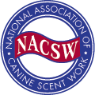

**K9 Nose Work®**

an overview

***This is an NACSW authorized workshop***

*Are you looking for something fun and different to do with your dog?*

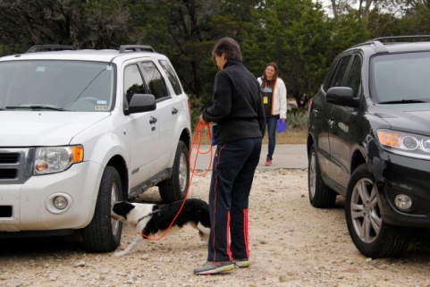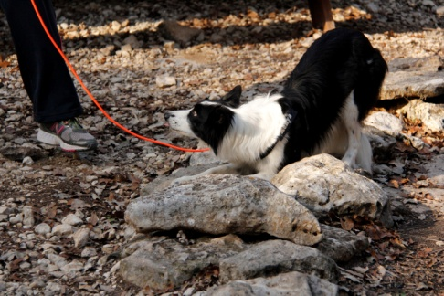***Try K9 Nose Work®!***

* Build your dog's focus and confidence
* Learn to read your dog’s body language
* Find an outlet for your dog’s energy

Join Diana Wilkins to learn more about this new, fun sport. The class will begin with an overview of K9 Nose Work®. Each of the four elements – Containers, Interiors, Exteriors and Vehicles – will be discussed, and working dogs will be introduced to each element.

LOCATION: K9 Country Club, 31305 Oak View, Bulverde, TX 78163

DATES: Saturday, March 21, 2015

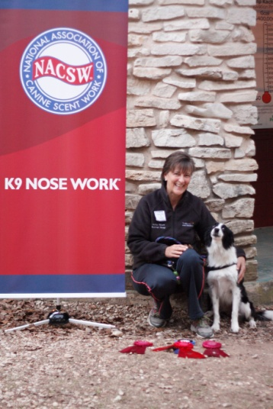TIME: 9:00 am – 5:00 pm

***… about Diana …***

In 2009, Diana moved to San Antonio, Texas to open In Harmony with Dogs, offering private training, behavior consultation, as well as classes in puppy socialization, dog obedience, and K9 Nose Work®.  Diana has also developed a K9 Nose Work® at the Animal Defense League that has successfully facilitated the adoption of many dogs.

Diana and her dogs have been actively involved in dog sports for many years. While Dani, her German Shepherd Dog, introduced her to agility competition, her Border Collie Kona took them to the next level. Diana and Kona consistently ranked at the top of the sport of dog agility and are eight-time finalists at the Cynosport World Championships, boasting five top ten finals placements.  Kenya, her younger Border Collie is also a talented agility competitor and excels in K9 Nose Work®. Most importantly, Diana enjoys the challenges of training at these levels and the teamwork that the sports facilitate with her dogs.

Register for this workshop:

Name: Contact Number:

Address: Email:

Pet's Name:

I would like a (circle one): Working spot Auditing Spot

Make Check Payable to K9 Country Club

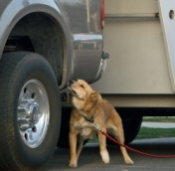**Working Spot (8 dogs total)**

This is a fun and full day for your dogs.The teams will be coached through common problem areas and gain productive exposure to different search exercises.

**Requirement and information for working teams:**

* One dog per handler
* All dogs will be crated in a designated area or in their vehicle when not working. Dogs should be quiet in car with people walking by or nearby.
* Dogs must be friendly or neutral/unconcerned with people in general. The working dogs may be in close proximity to groups of strangers in a novel environment.
* Working dogs should be able to walk calmly by another dog within 10 – 15 feet and have other dogs walk by their car. Reactive dogs should wear a red bandana and have a bandana on their crate to indicate their need for additional personal space.
* Any dog that is considered by the presenter or host to be under too much stress, a potential danger, or disruptive to the seminar will be asked to stop participating and/or leave. Refunds will not be issued to the handler of a dog who is excused for safety or health concerns based on the presenter's or hosts' determination.
* Dogs must be able to stay quietly in their vehicles out of sight from their handlers.

**Auditors (10-15)**  
If you prefer to observe or your dog does not meet the requirements, auditing is a perfect way to learn. Watching the teams work through search problem-solving provides many insights that will be directly applicable to you and your own dog. Please do not plan to bring your dogs.

**Video or audio taping and photography is permitted for your use only.**

**Seminar Cost:**

Payment is due at the time of registration and includes a continental breakfast, snacks, and lunch.

WORKING SPOT: **$120**

AUDIT: **$45**

**Cancellations:**

* Cancellations made on or before March 1, 2015 will be refunded
* No refunds after March 12, 2015, unless your spot can be filled from the waitlist



**830~980~8476 www.k9countryclub.net  
31305 Oak View Bulverde, TX 78163**